1. individually implemented classes/method

ID NUMBER-IT19051208 GROUP NUMBER- SE/OOP/B6/G8

SAKALASOORIYA S.A.H.A

|  |  |
| --- | --- |
| **File path** | **individually implemented classes/method name** |
| Src/dbUtill/  DoctorDButill.java | private void close(Connection myConn, Statement myStmt, ResultSet myRs) |
| public int[] dashboardSummary(int docid) |
| Src/dbUtill/  DoctorNoticeDButill.java | private void close(Connection myConn, Statement myStmt, ResultSet myRs) |
| public void createSpecialNotice(String title, String discription, int doctorID) |
| public void deleteDoctorNotice(int docNoticeID) |
| public List<DoctorNotice> getAllDoctorNotices(int doctorId) |
| public void updateNoticeDetails(int docNoticeID, String docNoticenDetails, String docNoticenTitle) |
| Src/dbUtill/  PatientDButill.java | private void close(Connection myConn, Statement myStmt, ResultSet myRs) |
| public List<Patient> getPatientSearchResults(String name_or_id) |
| public Patient getPatientInfo(int patient_id) |
| Src/dbUtill/  PriscriptionDButill.java | private void close(Connection myConn, Statement myStmt, ResultSet myRs) |
| public void deletePrescription(int prescriptionID) |
| public List<Prescription> getAllGivenPrescription(int doctorId) |
| public void updatePrescriptionDetails(int prescriptionID, String prescriptionDetails) |
| public List<Prescription> getAllPatientPrescriptionHistory(int patientId) |
| public Boolean savePrescriptionDetails(int patient_id, int doctot_id, String details) |
| Src/dbUtill/  UserDButill.java | private static void close(Connection myConn, Statement myStmt, ResultSet myRs) |
| public static User getUserInfo(int user_id) |
| public static int changePassord(int user_id, String password) |
| public static User validateLogin(String uname, String pword) |
| Src/ entities/  Prescription.java | public class Prescription |
| All getters in Prescription.java |
| Src/ entities/  User.java | public User(int userIDnumber,String userName, String userType) |
| public User( String fName, String lName, String dob, String address, String userType,String userName) |
| Src/ databaseConnection /  dataBaseConnection.java | public interface dataBaseConnection |
| Src/ databaseConnection /  dbConn.java | public class dbConn implements dataBaseConnection |
| Src/ hmsLogger/hmsLog.java | public class hmsLog |

individually implemented servlets

|  |
| --- |
| ChangePassword.java |
| DashboardController.java |
| Dashboardsummary.java |
| DoctorCreateNewNotice.java |
| DoctorDeleteNotice.java |
| DoctorDeletePrescription.java |
| DoctorGivenPriscription.java |
| DoctorManageNotices.java |
| DoctorSearchPatient.java |
| DoctorUpdateNotice.java |
| DoctorUpdatePrescription.java |
| DoctorViewPatientPrescriptionHistory.java |
| GetPatientDetailsServlet.java |
| InsertPrescription.java |
| UserProfile.java |

Screenshots of the user interfaces

login.jsp

[desktop view]

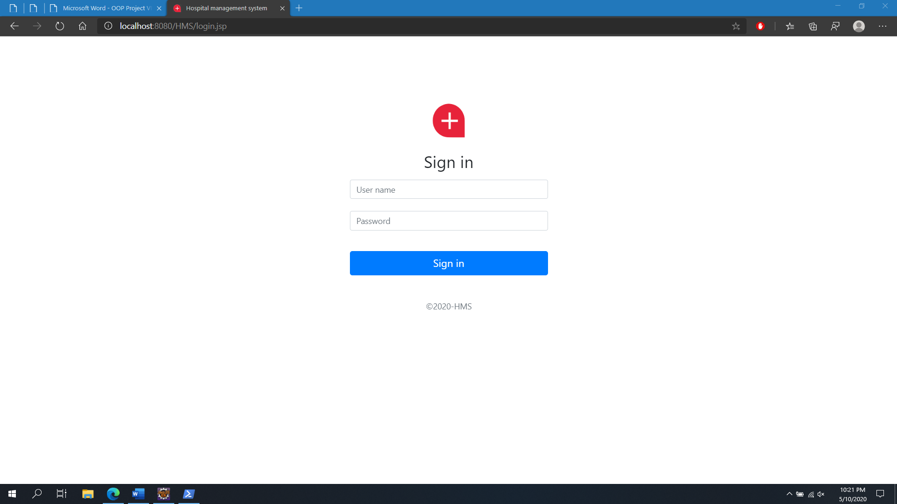

[mobile view]

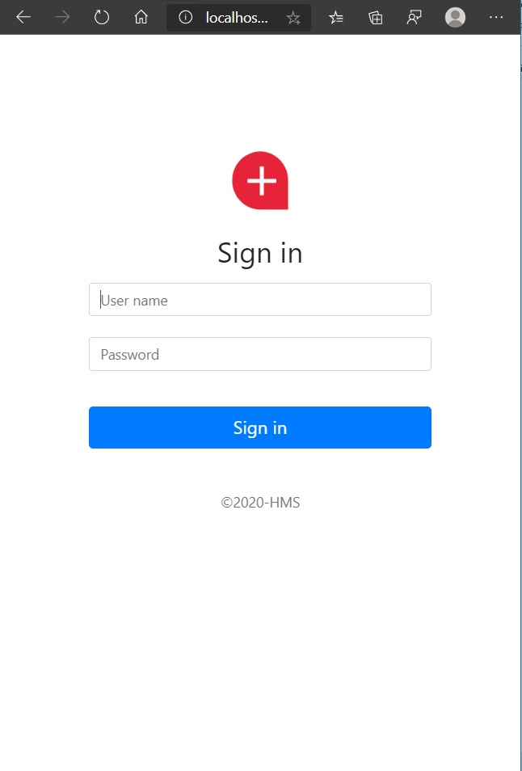

home.jsp

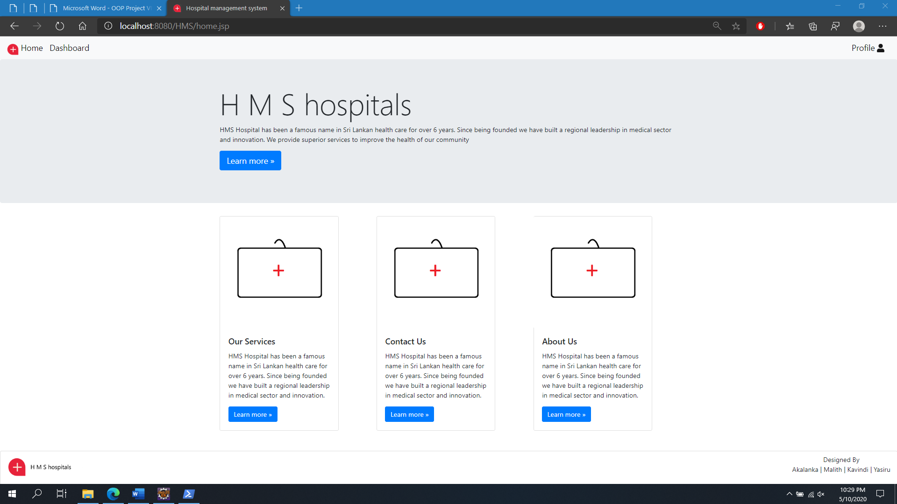

dashboardDoctor.jsp

[desktop view]

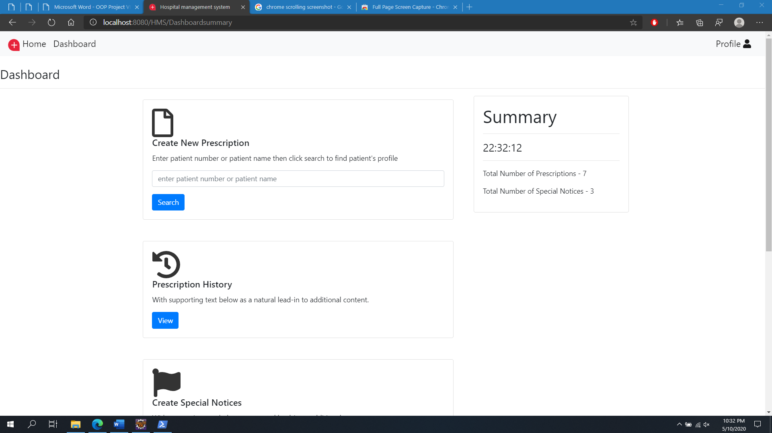

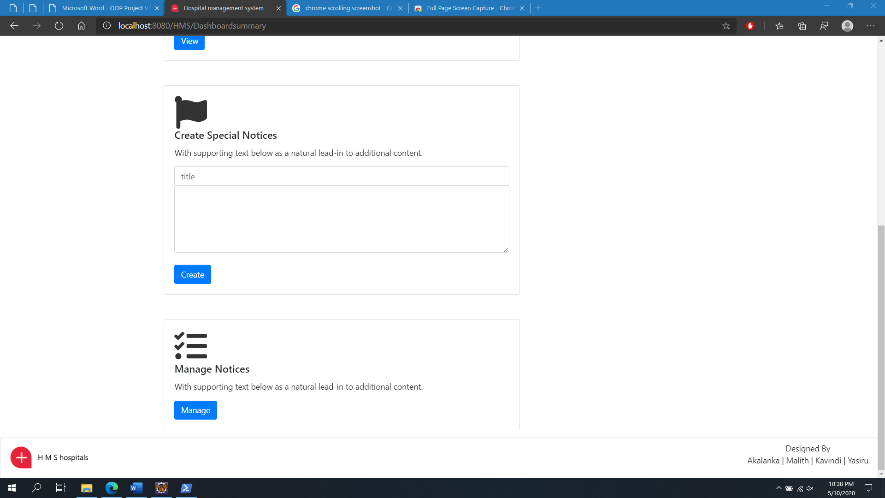

[mobile view]

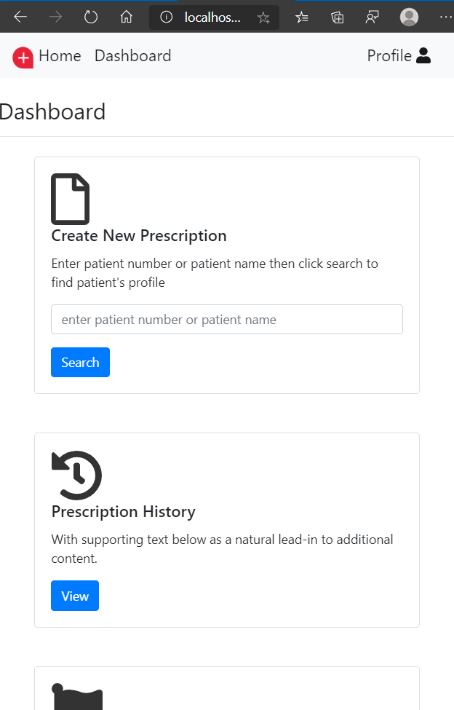

Profile.jsp

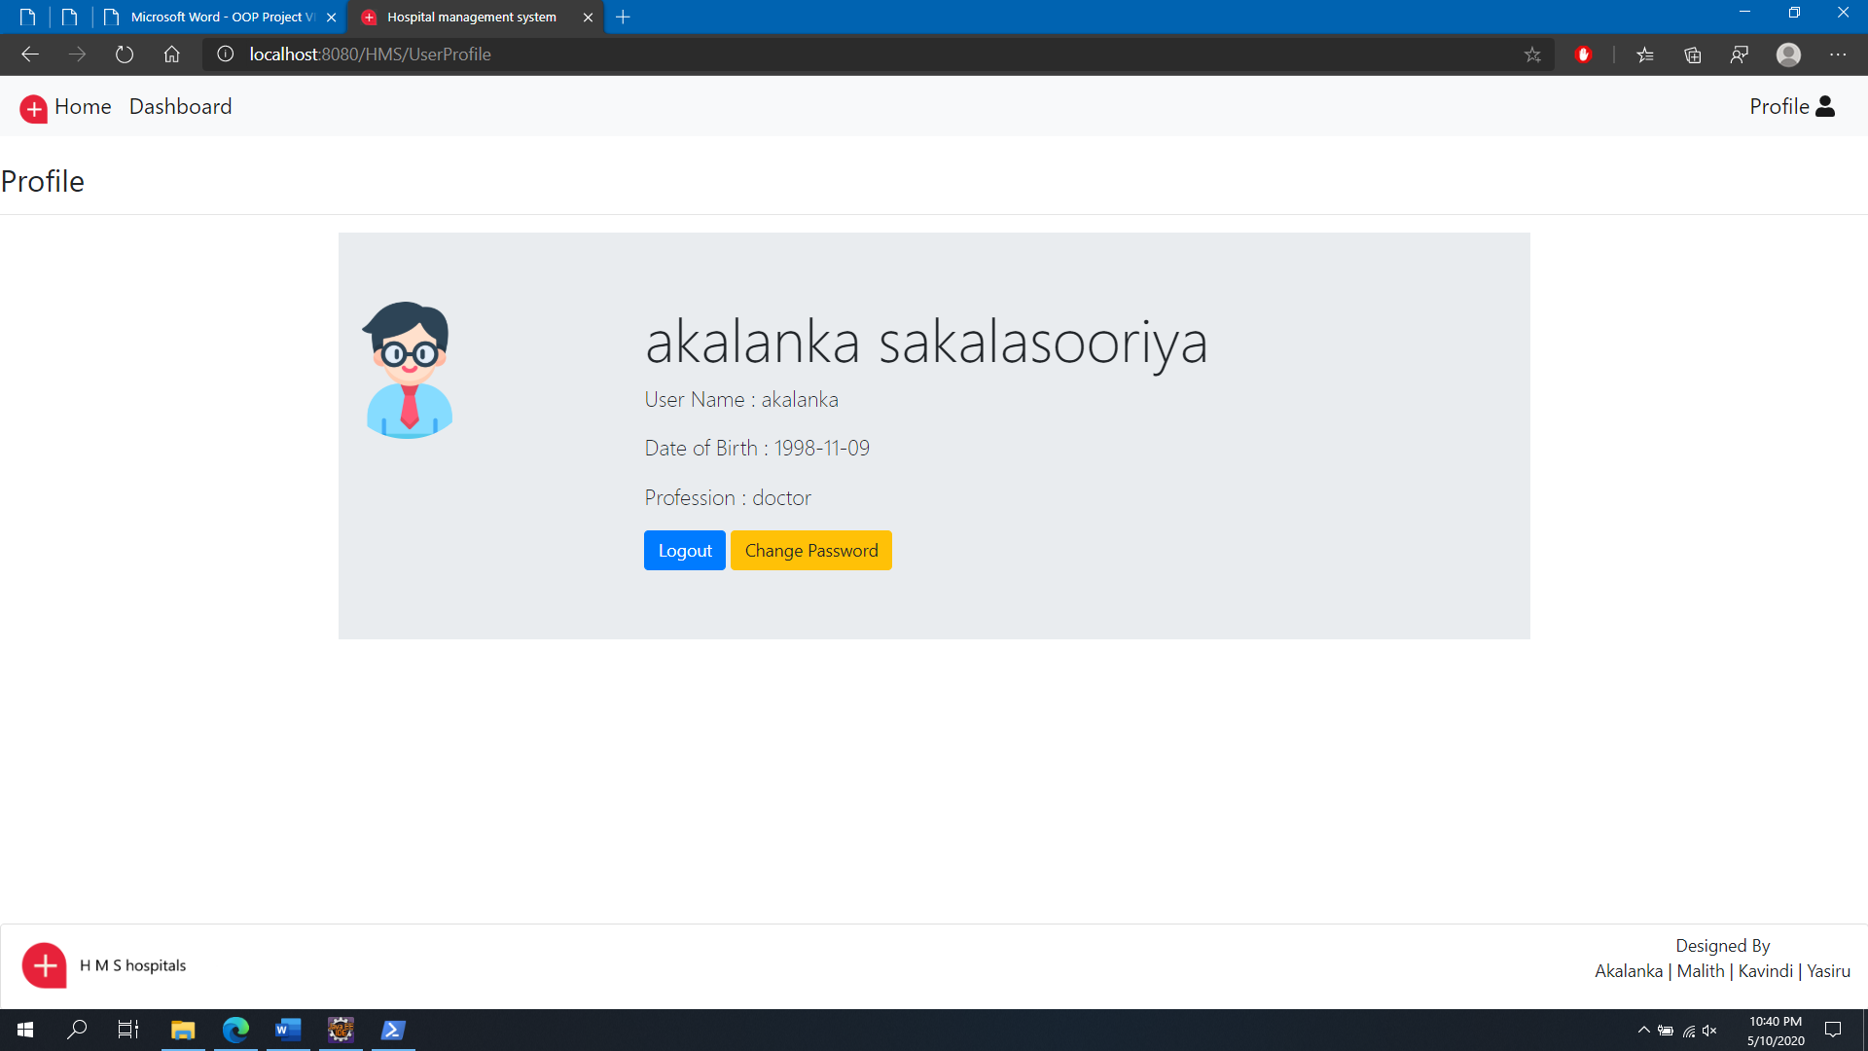

patientSearchResults.jsp

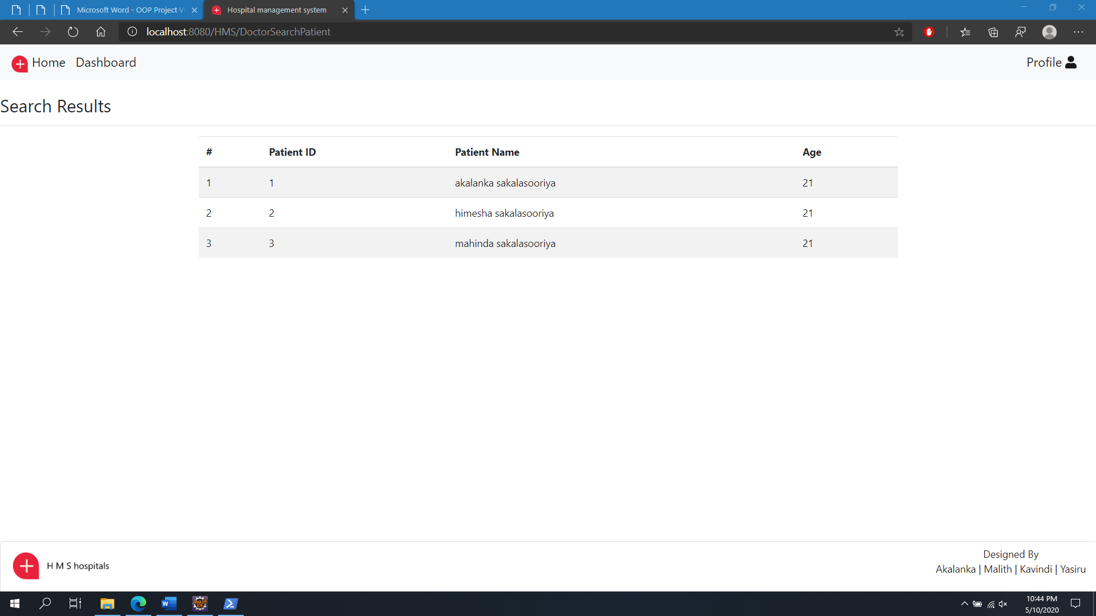

newPrescription.jsp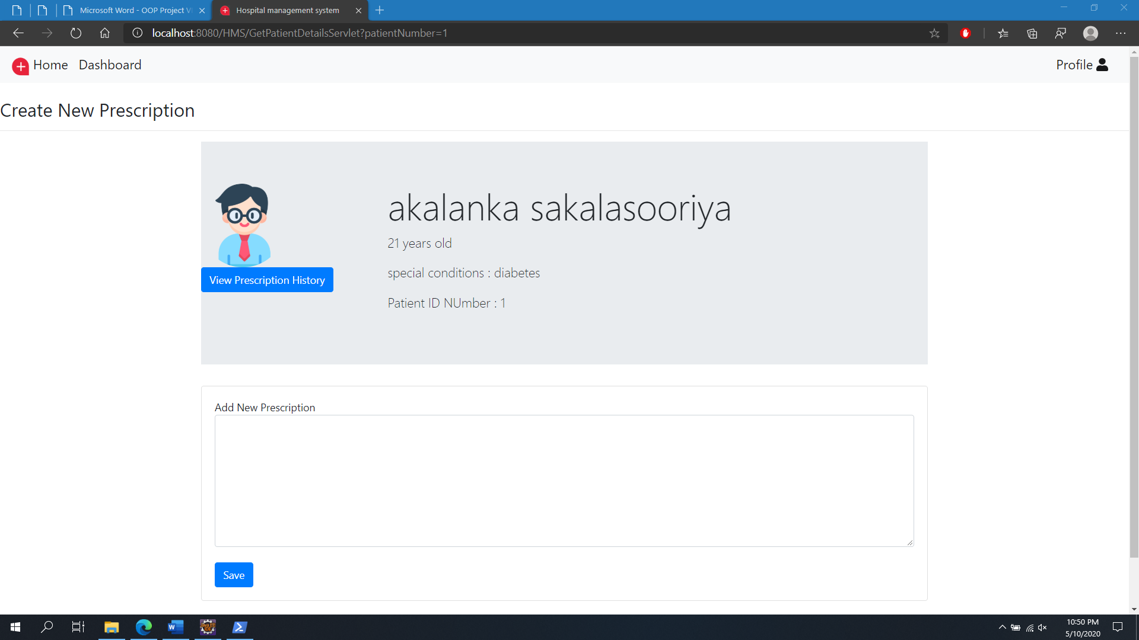

viewPrescriptionHistory.jsp

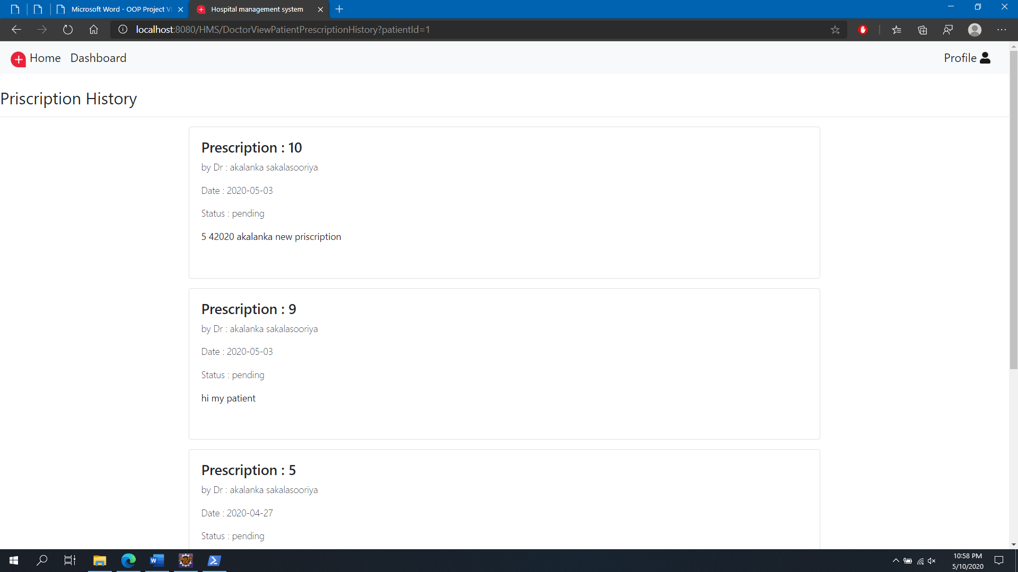

doctorPrescriptionHistory.jsp

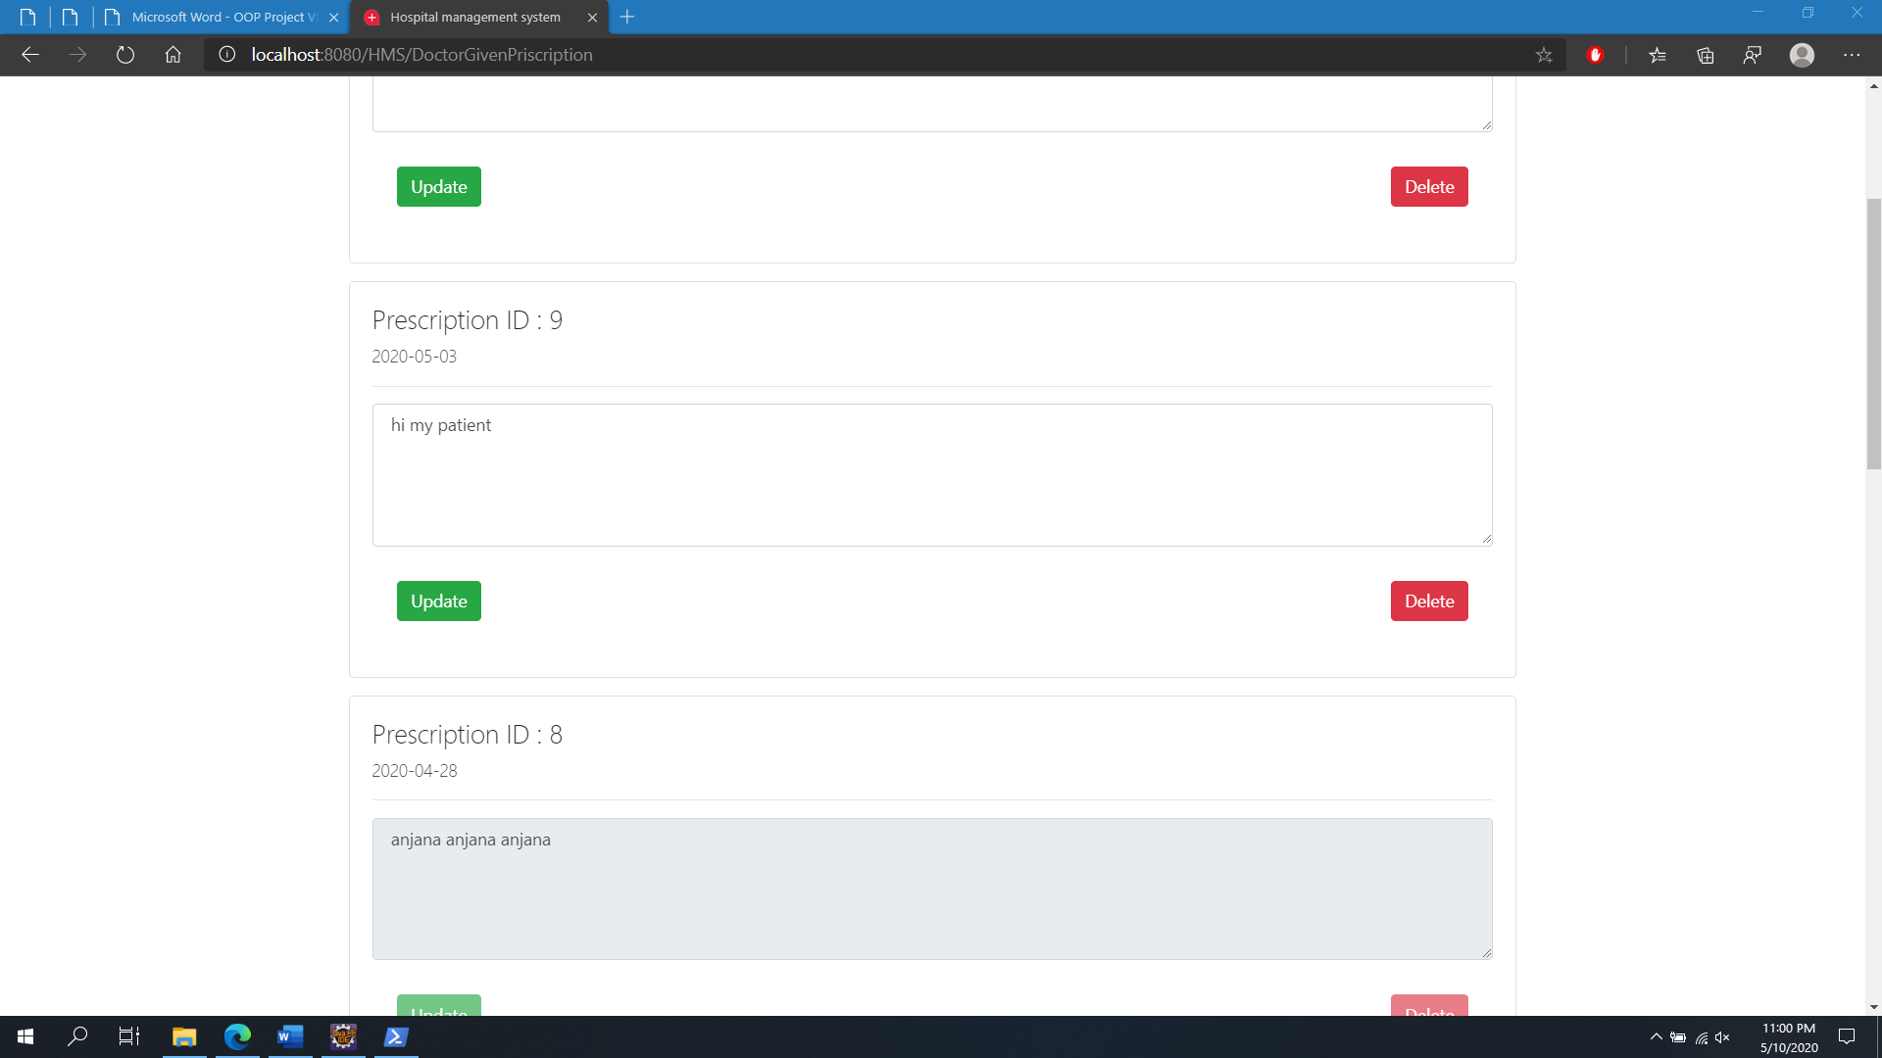

manageDoctorNotice.jsp

[desktop view]

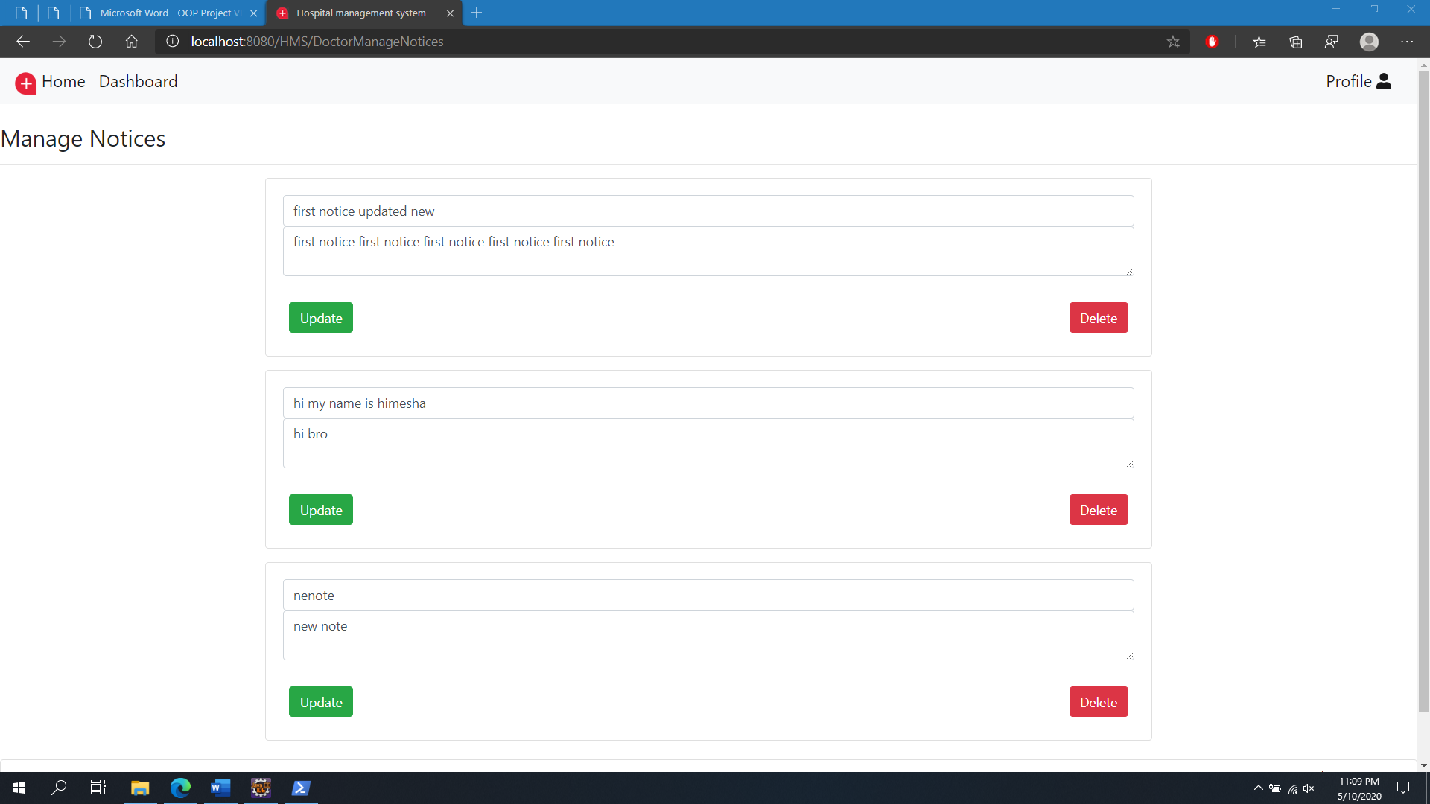

[mobile view]

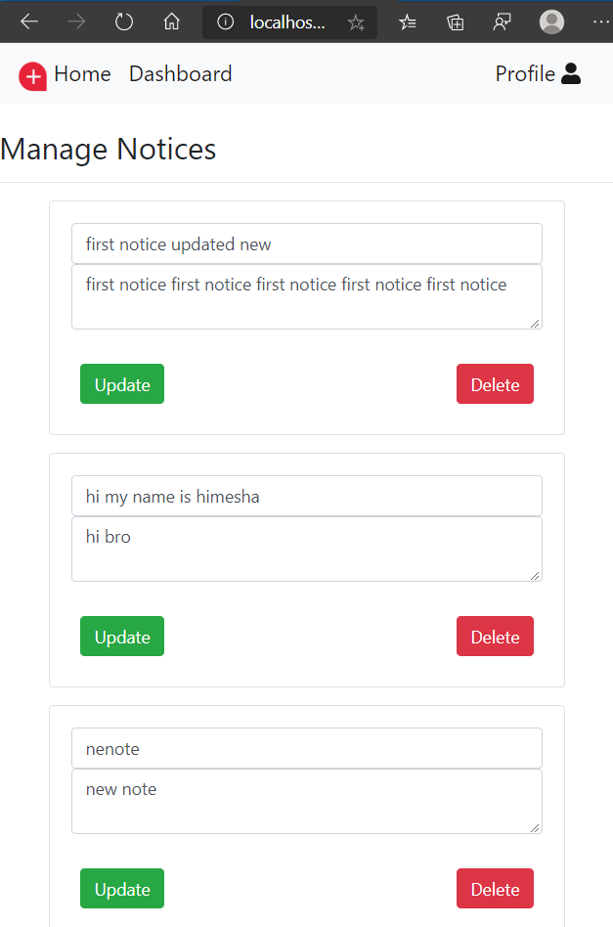

changePassword.jsp

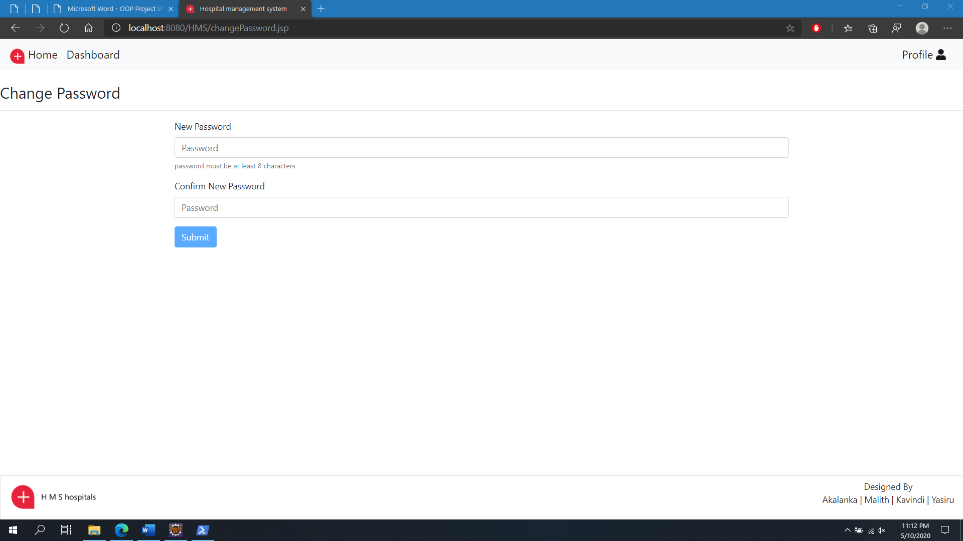

operationFaild.jsp

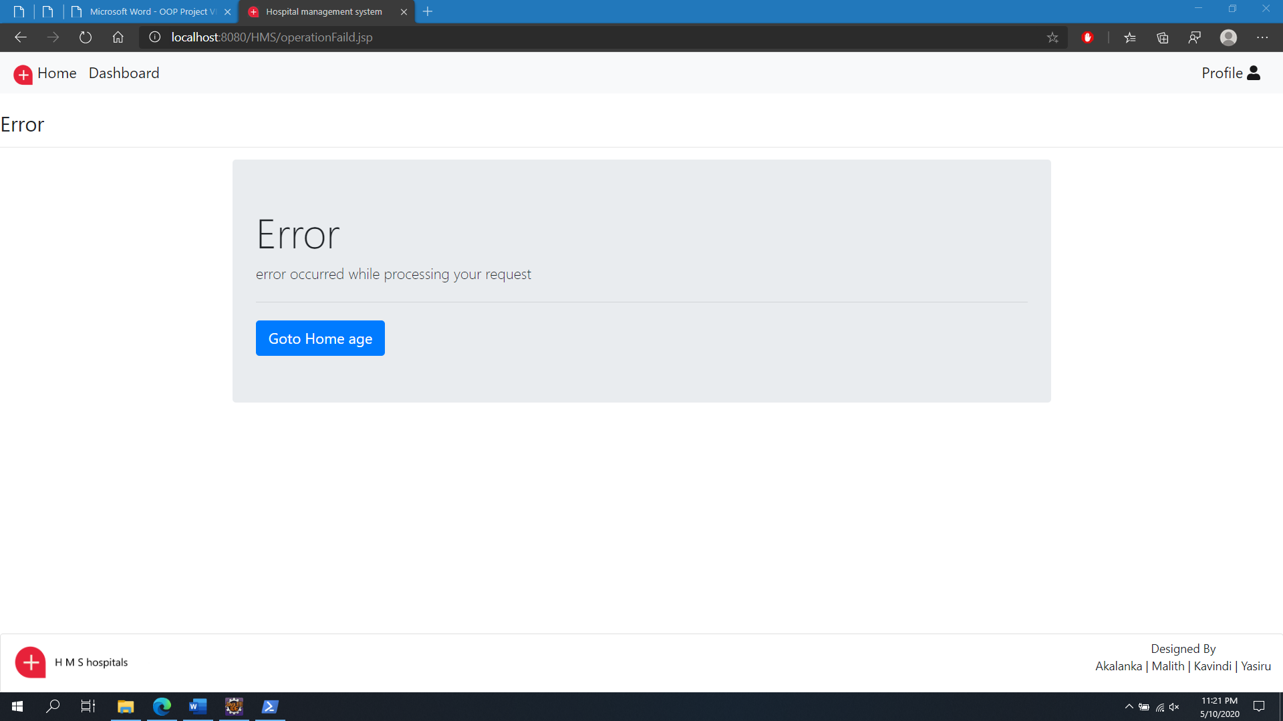

member rating

|  |  |  |
| --- | --- | --- |
| Name | Id number | Rating |
| Anjana W.W.M | IT19051376 | 1 |
| Wickramasinghe A.Y.S.W | IT19038292 | 1 |
| Fernando T.T.K.M | IT19059846 | 1 |